Door County Master Gardeners Association, Inc

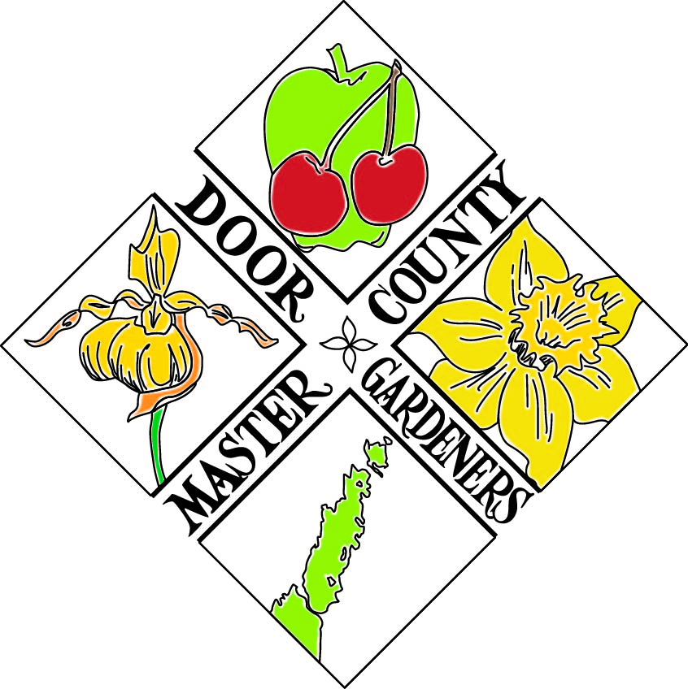

# (DCMGA)

# **Certified Master Gardener**

# **Volunteer Training Program Information**

**Our Mission Statement:**

The Door County Master Gardeners Association, Inc., in partnership with UW-Extension, shall strive to make a positive impact on horticulture in our community through education, community outreach, and stewardship of our environment*.*

**Why Join?**

Novices as well as knowledgeable gardeners are invited to become involved in our organization. With an emphasis on life-long learning as well as volunteerism, we are very proud of our **educational opportunities** and the many **service projects** in which we are involved.

Our Education Committee is one of the most active in the State. Each year we present several programs to our members as well as the public. The goal of these programs is to increase our horticultural knowledge and depth of understanding on a wide variety of topics. We’re also the only chapter in Wisconsin who is maintaining an educational show garden-The Garden Door.

The other part of our focus is our service to the community and we offer many service opportunities. We have a wide range of projects throughout the county. For example, some of our service hours have involved

* Maintaining The Garden Door – the educational & display garden mentioned above.
* Planning and planting flowers and bulbs outside of local public buildings
* Helping with our annual Plant Sale which funds our programs and The Garden Door
* Attending DCMGA committee or board meetings / serving on a committee or the board
* Helping to plan and/or present an educational program

There are many opportunities to express your interest in gardening!

**Who Can Join Master Gardeners?**

Again, novice or experienced gardeners are welcome to apply. Acceptance into class is based on both a background check through the UW Extension system and the order of all eligible applications received by the deadline. There is a class size limit of approximately twelve students per year. Individuals become certified in this volunteer organization of the UW Extension Service if they completed (within a training year) 36 hours of authorized education; and perform 24 hours of volunteer service. There will be ample opportunity within the training period to complete the required hours. It is expected that students participate in the green house and with the student project. Once the official training is concluded, to remain a Master Gardener Volunteer in Good Standing, a member must complete 24 hours of volunteer service and 10 hours of continuing education annually.

Every year the members of The Door County Master Gardener Association, Inc. meet to define our goals for the coming year and will occasionally define some of those goals as primary or of the utmost importance to the Association. It is expected that all members in good standing will be committed to participating in the activities that will help us to reach those goals.

## How the Training Program Works

Our program is not a college botany course. You will receive a training manual of resource information and access to many tutorials and videos online from the state Master Gardner, Level 1 Training Program. Our focus will be to provide a setting to attain a broader knowledge of horticulture through shared experiences and to orient you to our Association and the volunteer work we do. We bring in area experts and other Master Gardener volunteers to share their experience. We expect this year’s class members to attend our scheduled public educational programs whenever possible, as well as those offered only to our Association members plus complete the Mandated Reporter online course for reporting child abuse. Classes are held on Wednesday night from 5:30pm to 8:30pm from the first Wednesday in January to the last Wednesday in March.

***Planting in the greenhouse starts in March and concludes with the plant sale at the end of May.*** Students are expected to help plant seeds, transplant and maintain plants grown for the plant sale. It’s very important to understand that this will mean a large commitment of time over the next 9 months. Once the open-book take-home exam is taken and passed, and the volunteer hour requirements are met, trainees will be considered certified master gardener volunteers.

If you’re interested in having a mentor, a volunteer certified Master Gardener **mentor** could be assigned to you. Their role would be to act as a resource, source of support, and to help trainees understand and become involved in our organization. Please let the DCMGA Training Committee Chair know that you are interested in this feature. If you find yourself involved in an activity that you feel you need more one-on-one assistance, please let one of the committee members know so that we can have another member assist you.

**Fees**: $125 per person. Each person must fill out an application.

The non-refundable fee is charged to cover the cost of materials. This includes the Master Gardener Training Manual, current year’s membership dues in Door County Masters Gardeners Association, Inc and the Wisconsin Master Gardeners Association (WIMGA), and other miscellaneous expenses. This fee will be collected on the first night of class (Checks should be made payable to **Door County Master Gardeners Association** or **DCMGA)**. If this is a problem please let the Committee Chair know that in advance. If you would like to apply for a scholarship, please contact the Extension Door County office for an application.

**For more information on DCMGA**, check out our website at **www.dcmga.org**. The current issue of our comprehensive newsletter as well as previous ones can be found there as well as some references on what we do and enjoy. For any other questions or concerns, please contact our Training Coordinator, Carrie Sherrill. She can be reached by email at csherrill56@gmail.com

**The completed application form *must* be received by** the Extension Door County office in the Door County Government Center (421 Nebraska Street, Sturgeon Bay WI 54235) **by 12 Noon** **the last Tuesday in November**. [Office Hours are 8:00 to 4:30 Monday-Friday. The Extension Door County Office phone number is (920) 746-2260.]

If you are accepted, you will be notified and will be expected to attend the **first class meeting**. **The first class will be held the second Wednesday of January at 5:30pm**. Class will be held at Crossroads at Big Creek in Sturgeon Bay.

Door County Master Gardeners Association, Inc (DCMGA)

Certified Master Gardener Training Program Application Form

### Name of Applicant_____________________________________________________________________

*Name of Co-Applicant (if any) _________________________________________________________

Address______________________________________________________________________________

Phone___________________________ E-Mail ______________________________________________

Fee: TBD (*Fees will be collected at the first class)*

1. Please explain why you wish to become a Master Gardener Volunteer. List the ways you feel you’ll best be able to contribute to the group.

2. In future years, one of the requirements to maintain your certification is to contribute 24 hours of volunteer service. We have a wish that at least some portion of that be spent in maintaining the Garden Door Educational Garden and/or volunteering for events held there. We also know that free time varies for everyone. Considering the amount you have available, roughly how many volunteer hours do you think you would want to contribute annually?

3. Please list things you enjoy doing that might be of benefit to the advancement of our group’s Mission Statement.

1. What DCMGA public programs have you attended in the past?

5. Are there any areas of gardening in which you would especially like mentoring (propagation, landscaping, plant choices, meeting other members, having someone to go to programs with, etc)?

6. The following topics will give us an idea of areas in which you might be active in DCMGA.

*Consider this just a starting point, since we’ll be explaining these possibilities for you within the training program.*

**Rate the topics according to your Interest / Anticipated Activity Level:**

*1 = Highest interest 2=Some interest 3=Possible interest (Blank = No interest)*

#### To fulfill my **EDUCATION HOURS:**

#### _____ Attend DCMG Public Education Programs _____ Attend Hands-On Workshops

#### _____ Visit Gardens _____ Attend Online Resources Session

_____ Attend Area / State / Tri-State Conferences _____ View WI Gardener PBS Programs

_____ View selected videos about gardening _____ View other approved gardening TV programs

_____ Attend Roundtable Discussions on Gardening_____ Attend other horticultural education programs

# To fulfill my **SERVICE HOURS:**

_____ Help with Plant Sale _____ Contribute to DCMGA Newsletter

_____ Help the Garden Door Committee _____ Help the Education Committee plan programs

_____ Help the Finance Committee _____ Help the Stewardship Committee

_____ Help the Training Program Committee _____ Join the governing Board

_____ Be an officer _____ Help Publicity Committee

_____ Help with our website _____ Give a tour of a garden

_____ Bake cookies for public programs _____ Be a Q&A panel member

_____ Annual meeting/banquet planning _____ Help plan social events

_____ Help with videography / photography _____ Represent DCMGA at State

_____ Help conduct a workshop _____ Work in Garden Door Display Garden

_____ Help in community gardens _____ Help set up public programs

_____ Help control invasive plants _____ Help with a youth gardening project

_____ Participate in DCMGA program radio shows (i.e.: WDOR with Eddy Allen)

_____ Other: _________________________________________________________________

#### 

By signing this application I have agreed to attend 36 hours of training AND contribute a total of at least 24 hours of volunteer service in Door County Master Gardeners Association approved project(s). Upon acceptance into the Door County Master Gardeners Association Training program, I also agree to complete the required criminal background check. This is a requirement of UW Extension system and the Wisconsin Master Gardeners Association.



I understand that once I complete the required training educational hours, pass the final exam, and contribute 24 hours of volunteer time, I will be a certified Master Gardener Volunteer in Good Standing.

I further understand that this covers my initial training year and in order to maintain my status in future years as a Master Gardener Volunteer in Good Standing, I will need to annually complete 24 hours of volunteer service, 10 hours of continuing education hours and pay membership dues as designated by the Board to remain a Master Gardener Volunteer in Good Standing.

Signed_________________________________________________Date__________________________

**The completed registration form must be received by** **12 Noon** **the last Tuesday in November**

at the Extension Door County office in the Door County Government Center.

Mailing Address: 421 Nebraska Street, Sturgeon Bay WI 54235 Phone: 920-746-2260